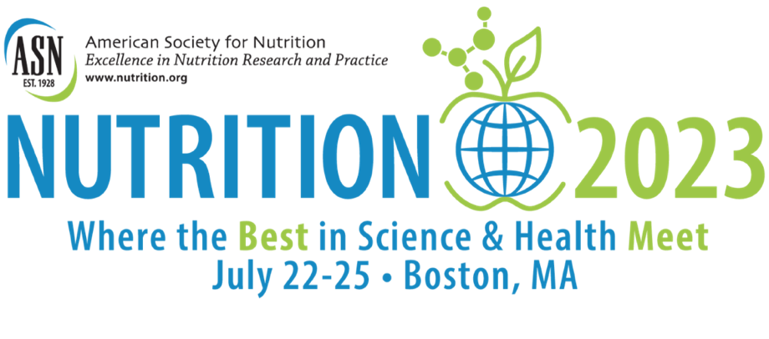
SAMPLE SOCIAL MEDIA POSTS

Follow/Tag ASN:
Twitter - https://twitter.com/nutritionorg
Facebook - https://www.facebook.com/AmerSocNutr
Instagram - https://www.instagram.com/americansocietyfornutrition/
LinkedIn - https://www.linkedin.com/company/american-society-for-nutrition

General (Before NUTRITION 2023, July 22-25)
Following three years of virtual meetings, #Nutrition2023 offers a unique opportunity to reconnect in-person with top experts in the field, meet new collaborators and access the latest science. Join me in Boston, MA, July 22-25! https://nutrition.link/N23-Boston

Join me at #Nutrition2023–– a homecoming for the nutrition community! Taking place in-person in Boston, MA, July 22-25, NUTRITION 2023 is the can’t miss nutrition event of the year featuring timely topics in nutrition. https://nutrition.link/N23-Boston

Who’s coming with me to #Nutrition2023? I’m looking forward to being back in-person and accessing the latest in science in Boston, MA, July 22-25! https://nutrition.link/N23-Boston

I’m attending #Nutrition2023 in Boston, MA, July 22-25! Join me for 3.5 exciting days in Boston to celebrate the return of an invigorating, inspiring, and educational gathering of the nutrition community. Register and learn more at: https://nutrition.link/N23-Boston

Connect with me at #Nutrition2023 in Boston, MA, July 22-25! Meeting in-person is a refreshing change of pace that will ignite new perspectives and new connections I am looking forward to. https://nutrition.link/N23-Boston

Early Registration (March 2023 – April 28, 2023)
Don’t miss the chance to register for #Nutrition2023 with the Early Registration discount. Join thousands of nutrition professionals in Boston, MA, July 22-25. Register by April 28th for the best rates! https://nutrition.link/N23-early-reg

Advance Registration (April 29, 2023 – June 9, 2023)
Don’t miss the chance to register for #Nutrition2023 at the Advance Registration rate. Join thousands of nutrition professionals in Boston, MA, July 22-25. Register by June 9th to save! https://nutrition.link/N23-Boston

Suggested hashtags:
#Nutrition2023
#Nutrition
#NutritionEducation
#NutritionOrg
#NutritionScience
#NutritionExpert
#NutritionProfessional
#NutritionResearch
#NutritionNews
#NutritionCommunity
#ScienceCommunity
#Academic
#Health
#LatestResearch

Ideas for Writing Your Own Posts
We encourage you to have fun and write your own social media posts! Here are a few thought-starters for inspiration:

- Are you a first-timer or returning NUTRITION attendee?
- What tips do you have for getting the most out of an in-person professional meeting?
- What sessions are you most looking forward to?
- What do you want to learn more about?
- Who do you want to meet?
- Which exhibitors do you plan to visit?
- What can you offer to other attendees?
- What else do you plan to do in Boston?

Graphics:
